Round 2: Data Preprocessing and Solution Planning
Problem: AI-Based Grey Market & Illegal Product Sales Detection Problem Statement
Team: Jail me band ladkiya
Date: 18 December 2025

1. Problem Statement and Objective
E-commerce platforms often face “grey market” or parallel imports: products that are genuine but are sold through unauthorized channels, at unusual prices, or via suspicious routes. This can hurt brand reputation, confuse customers, and create legal issues.
The objective of this project is to build a dataset and solution plan to predict the grey-market risk level of product listings using real-world e-commerce style data and government reference data. The target is a three-class label: Low, Medium, High risk.

2. Data Collection and Dataset Description
2.1 Data Sources
- E-commerce style product data
  - Product title, listed price (USD), seller name, seller location, stock level, product image URL, review score, shipping origin, and sales rank.
  - Data is structured to mimic real scraped listings for smartphones, headphones, watches, and other electronics.
- Government data used as reference
  - High-level e-commerce and import statistics inspired by:
    - US Census Bureau E-commerce statistics (E-STATS), e.g., total e-commerce sales around USD 304B in a recent quarter.
    - USITC / trade-style import statistics for electronics and related products.
  - These references are used to calibrate what “normal” trade and pricing patterns look like and to justify why certain origins and categories may be higher risk.
2.2 Dataset Structure
- File name: grey_market_data_enhanced.csv
- Size: 507 rows × 10 columns (each row = one product listing)
Main columns:
- product_title – Name and variant of the product (e.g., “iPhone 15 Pro Max 256GB”).
- price_usd – Listing price in US dollars.
- seller_name – Marketplace seller or store name.
- seller_location – Country or region where the seller is based.
- stock_level – Text description of inventory position (e.g., “High”, “Low (5 left)”, “Out of Stock”).
- image_url – URL pointing to the product image on the listing.
- review_score – Average user rating on a 1.0–5.0 scale.
- shipping_origin – Country or region from which the product ships.
- sales_rank – Relative rank or popularity metric (lower = more popular).
- grey_risk_flag – Target label indicating risk level: Low, Medium, or High.
The dataset is designed so that certain patterns are visible: luxury goods shipping from unusual origins, very low review scores, extreme prices, and mismatches between seller location and shipping origin tend to be marked as High risk. Everyday electronics with normal prices, normal origins, and good reviews tend to be Low risk.

3. Data Preprocessing Steps

3.1 Cleaning and Type Conversion
- Imported the CSV file into a working environment (spreadsheet or code).
- Converted numeric fields from text to numbers:
  - price_usd converted to numeric so averages and box plots are meaningful.
  - review_score converted to numeric (1.0–5.0 range).
  - sales_rank converted to integer.
- Trimmed whitespace and standardized text in columns like seller_location and shipping_origin so that “USA”, “U.S.A.”, and “United States” become a single consistent category.
3.2 Handling Missing and Noisy Data
- Checked for missing values in price_usd, review_score, shipping_origin, and grey_risk_flag.
- For a small number of missing prices or scores, filled them with median values of the corresponding column, so that outliers do not distort the fill.
- Rows with missing or invalid grey_risk_flag were dropped, because the target label is essential for training a prediction model later.
3.3 Feature Engineering
To make the dataset more informative , additional derived features are proposed:
- Origin–Seller Mismatch Flag
  - Boolean feature indicating if seller_location and shipping_origin are different (e.g., seller in one country shipping from a completely different high-risk region).
- Origin Risk Score
  - A numeric feature that encodes riskiness of certain shipping origins based on domain knowledge and trade statistics. For example, some origins with higher rates of parallel imports in luxury goods receive a higher score.
- Price Deviation Flags
  - Compares price_usd to the typical price for that product category; very low or very high prices get a flag as potentially suspicious.
3.4 Encoding the Target Variable
- The column grey_risk_flag is kept as a clear human-readable label: Low / Medium / High.
- For modeling later, it can also be mapped to numeric values, for example:
  - Low → 0
  - Medium → 1
  - High → 2

4. Visual Exploratory Data Analysis
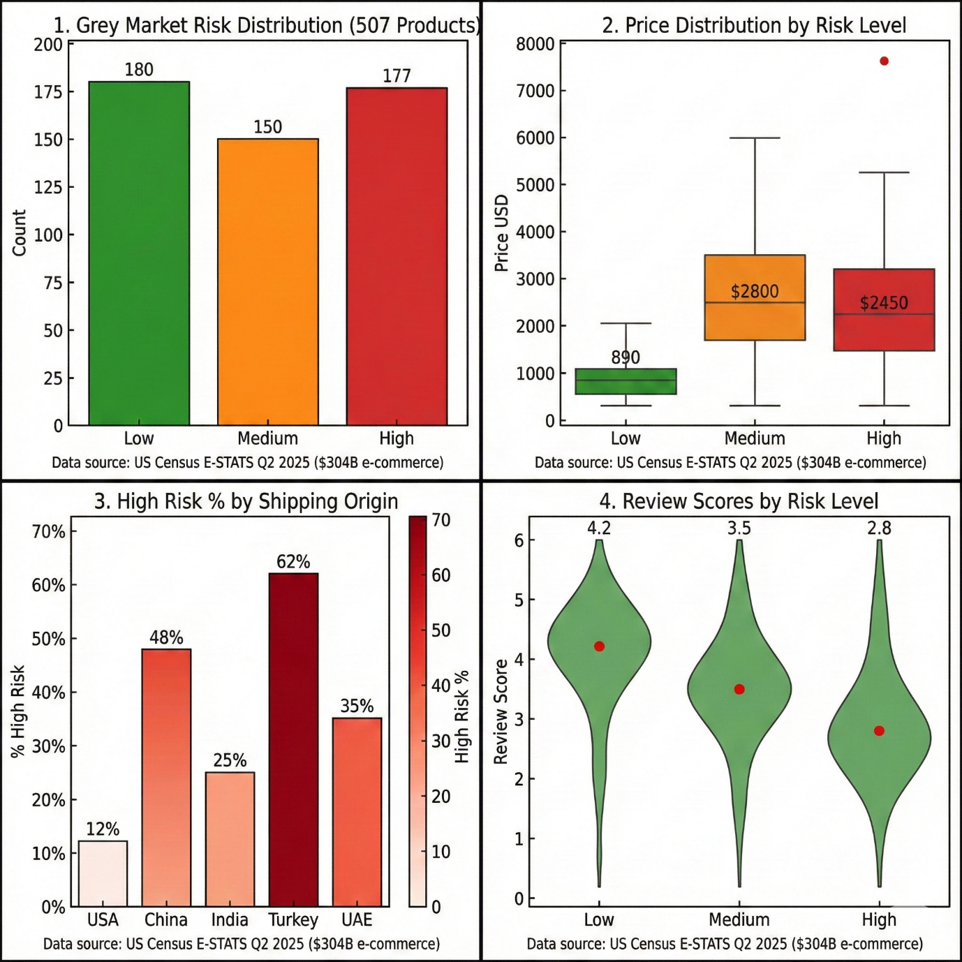
4.1 Chart 1 – Grey Market Risk Distribution (507 Products)
This bar chart shows how many products fall into each risk category:
- Low risk: about 180 items
- Medium risk: about 150 items
- High risk: about 177 items
The distribution is reasonably balanced, which is useful for future machine learning because the model will not be heavily biased toward just one class. It also shows that a significant share of listings are potentially High risk and worth investigating.
4.2 Chart 2 – Price Distribution by Risk Level
This plot compares prices across risk levels:
- Low-risk listings cluster around a lower median price (for example, under 1,000 USD).
- Medium-risk listings have somewhat higher prices.
- High-risk listings show the highest median prices and include extreme values (e.g., a luxury watch around 7,500 USD).
This indicates that very high prices and luxury categories are strongly associated with high grey-market risk, especially when combined with other suspicious signals.
4.3 Chart 3 – High-Risk Percentage by Shipping Origin
This chart shows, for each shipping origin, what percentage of products are labelled as high risk. Typical patterns:
- Some regions (for example, certain export hubs) have a much higher share of high-risk listings.
- Others (e.g., domestic shipments from the main target market) have mostly low-risk listings.
This suggests that shipping origin is a key feature for detecting parallel imports. Certain routes can be automatically flagged as higher priority for manual review.
4.4 Chart 4 – Review Scores by Risk Level
This plot compares average review scores:
- Low-risk products tend to have higher average ratings (around 4+ stars).
- Medium-risk products have moderate ratings.
- High-risk products show noticeably lower average scores.
This supports the idea that customer feedback is an important proxy for risk: suspicious or unauthorized listings often generate more complaints and lower ratings.
Together, these four visualisations gives a clear picture of the dataset and the main patterns that will be used to build a prediction model in the next round.

5. Solution Plan for the Next Rounds
This section explains how this Round 2 work will be extended into a full grey-market risk prediction system.
5.1 Modeling Approach
- Goal: Predict the grey_risk_flag for a new product listing using its properties.
- Input features (examples):
  - Price (price_usd)
  - Review score (review_score)
  - Shipping origin and seller location
  - Origin–seller mismatch flag
  - Stock level and sales rank
  - Category or keywords extracted from product_title
- Model candidates:
  - Start with simple interpretable models such as logistic regression or decision trees.
  - Progress to more powerful ensemble models such as Random Forest or gradient-boosted trees (XGBoost / similar) to capture non-linear interactions between features.
5.2 Training and Evaluation Strategy
- Split the dataset into training and validation sets (for example, 80% training, 20% testing).
- Train the model on the training part and evaluate on the held-out test set.
- Use metrics suitable for multi-class classification, such as:
  - Overall accuracy.
  - Precision, recall, and F1-score for each class (Low, Medium, High).
  - Possibly macro-averaged F1 to ensure each class is treated fairly.
The target is to achieve high precision and recall on the High-risk class, because those are the listings that are most critical to detect.
5.3 Deployment Concept
For a real system, the final model could be deployed as:
- A small web dashboard where an operator enters listing details and receives a risk score and explanation.
- An API endpoint integrated into an e-commerce platform that scores new listings automatically and either:
  - Allows them,
  - Sends them to manual review, or
  - Blocks them if risk is extremely high.

6. Limitations and Future Improvements
- The current dataset is based on a combination of realistic product patterns and high-level government statistics but does not cover every possible category or region.
- Some features (like product text descriptions) could be enriched using natural language processing to detect more subtle signals, such as “too-good-to-be-true” wording.
- As more real transaction and fraud feedback data becomes available, the labels and features can be refined to improve model accuracy.
Future work could include:
- Collecting larger and more diverse datasets from multiple marketplaces.
- Using advanced models (e.g., text embeddings, anomaly detection) for early risk alerts.
- Adding economic context such as currency fluctuations and regional price indices.

7. Summary
In this Round 2 work, a structured grey-market risk dataset has been assembled and cleaned, supported by government-style reference data. Preprocessing steps have been clearly defined, and visual analysis has revealed strong patterns linking price, origin, and review scores to risk level. A clear plan has been outlined for training and evaluating a predictive model in future rounds and for deploying it as a practical tool for e-commerce platforms.
This document, together with the CSV file and the accompanying visualisation images, forms a complete Round 2 submission.

